The University Of Azad Jammu & Kashmir

Student Name : Qurat Ul Ain Fatima
Roll No : 2024-SE-05
Course Title : Digital Image Processing
Lab Instructor : Engr. Fahad Nisar
Department : Software Engineering

LAB#03
1. Objective:
To calculate, implement, and compare grayscale intensity transformations, histogram enhancement, and thresholding while preventing overflow and understanding their effects.

2. Requirements:
- Python 3
- Jupyter Notebook or VS Code
- NumPy
- OpenCV
- Matplotlib
- One JPG or PNG image (at least 300 × 300 pixels)

3. Common Setup and Image Validation:
Steps:
- Create a Jupyter Notebook (.ipynb).
- Import OpenCV, NumPy, and Matplotlib.
- Load an image in grayscale format.
- Check whether the image is loaded successfully.
- Display the image shape, data type, minimum value, and maximum value.
- Keep the original image unchanged.
- Create separate arrays for every image transformation.

TASK 1: Brightness Adjustment:
Objective: To increase and decrease image brightness.
Original Image:
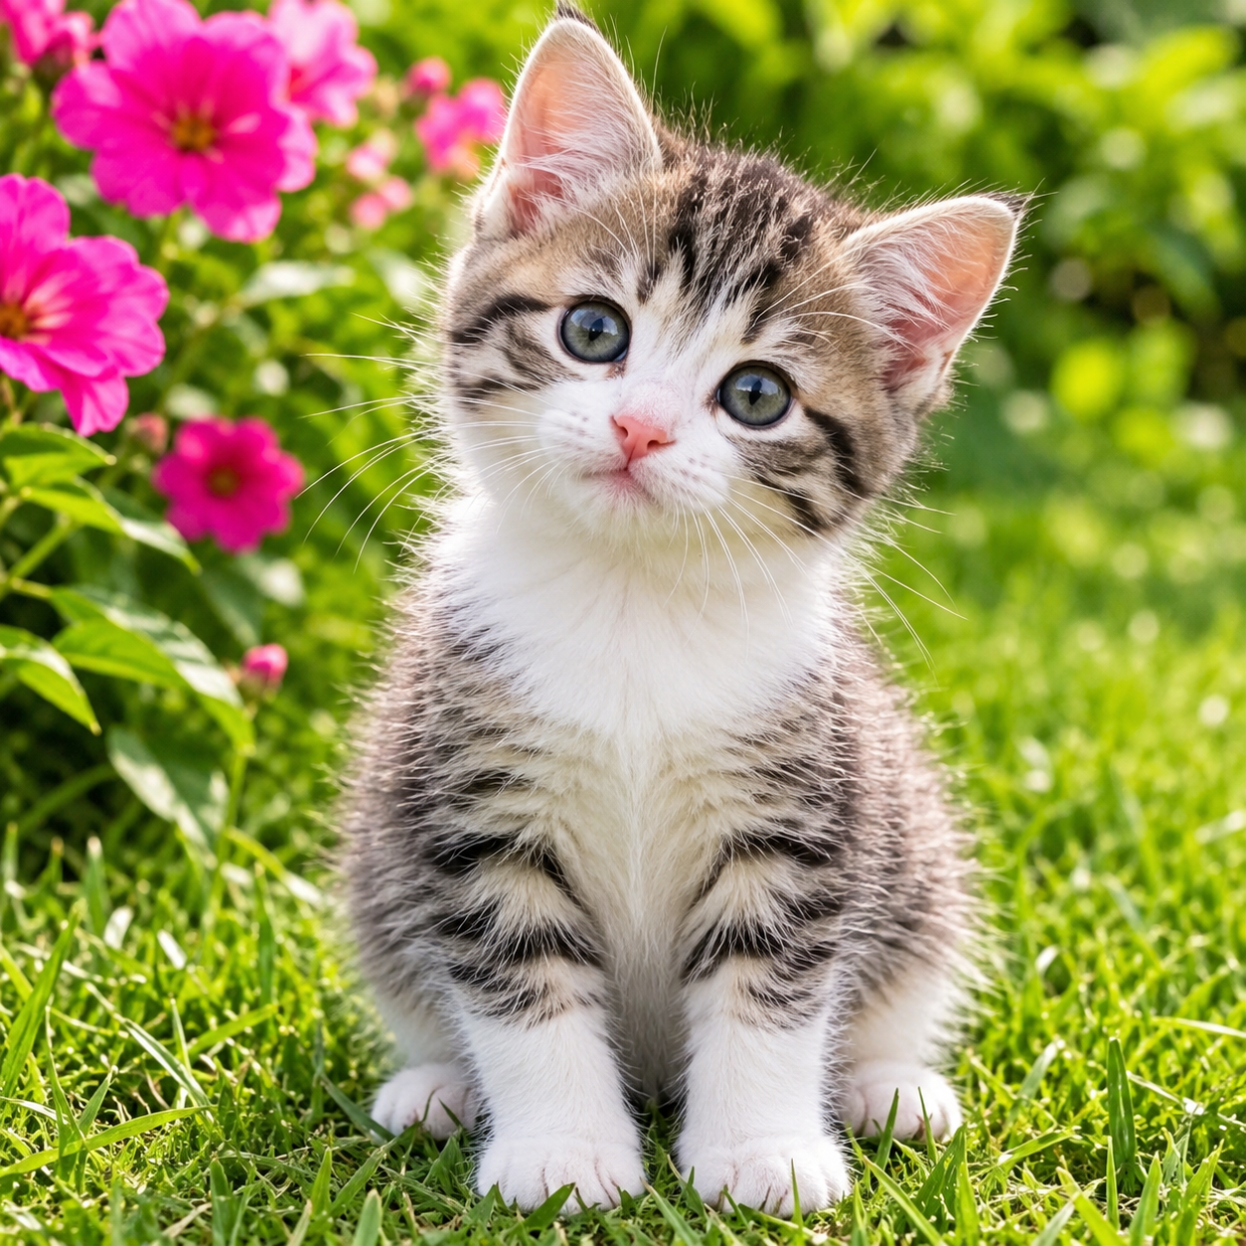
Formula:
s = r + β
Where:
- r = Original pixel value
- β = Brightness adjustment (+40 or −40)

Dry Run
Original pixels:
[30, 80, 128, 180, 240]
Brightness +40
30 + 40 = 70
80 + 40 = 120
128 + 40 = 168
180 + 40 = 220
240 + 40 = 280 → 255
Final output:
[70, 120, 168, 220, 255]
Brightness −40
30 − 40 = −10 → 0
80 − 40 = 40
128 − 40 = 88
180 − 40 = 140
240 − 40 = 200
Final output:
[0, 40, 88, 140, 200]

Practical Steps:
- Convert the original image into a wider data type.
- Add 40 to every pixel to create a brighter image.
- Subtract 40 from every pixel to create a darker image.
- Clip the results between 0 and 255.
- Convert the results into uint8.
- Display the original, brighter, and darker images.
- Implement brightness +40 using nested loops.
- Compare the nested-loop result with the NumPy result.
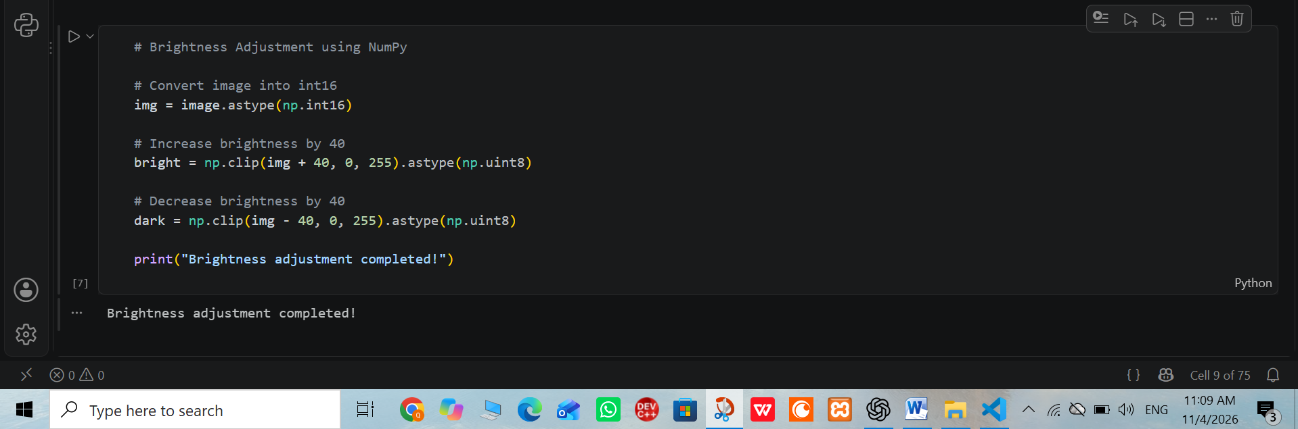

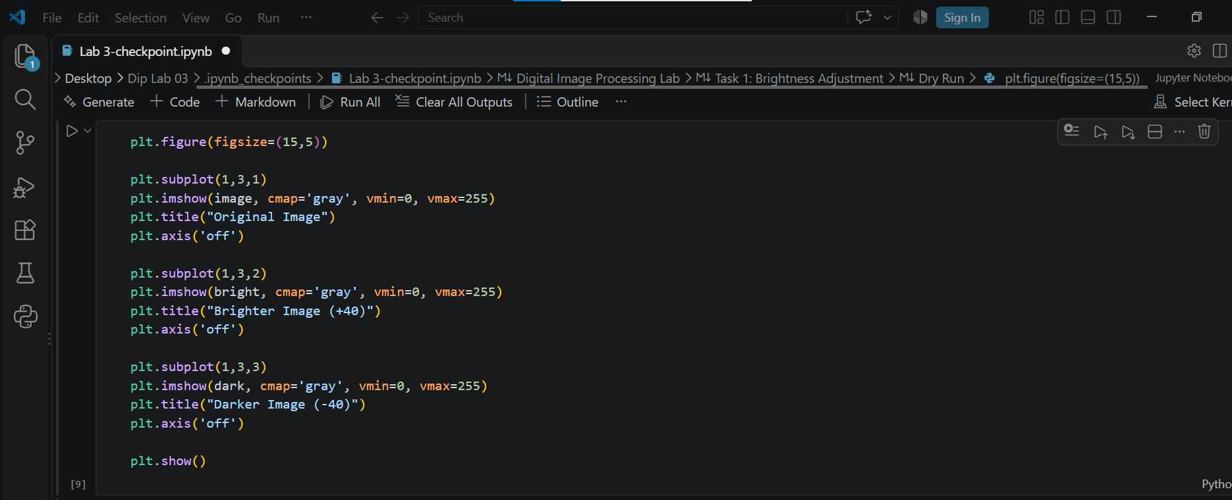
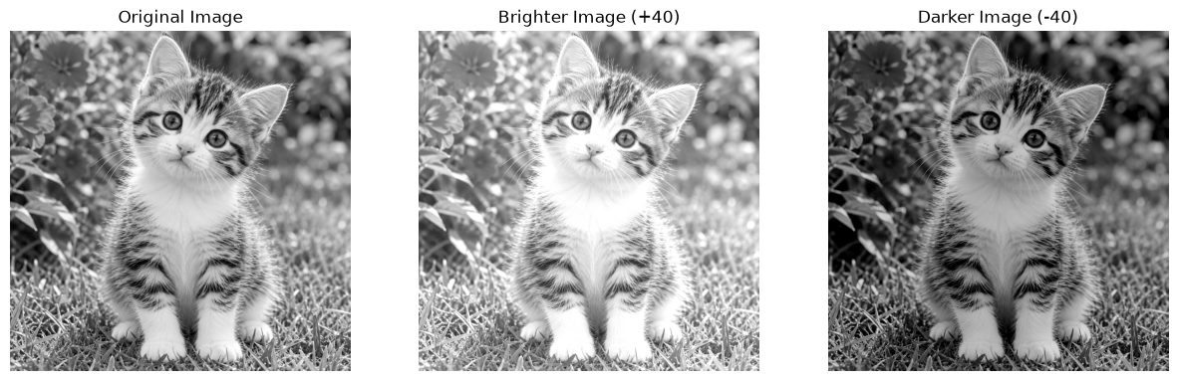
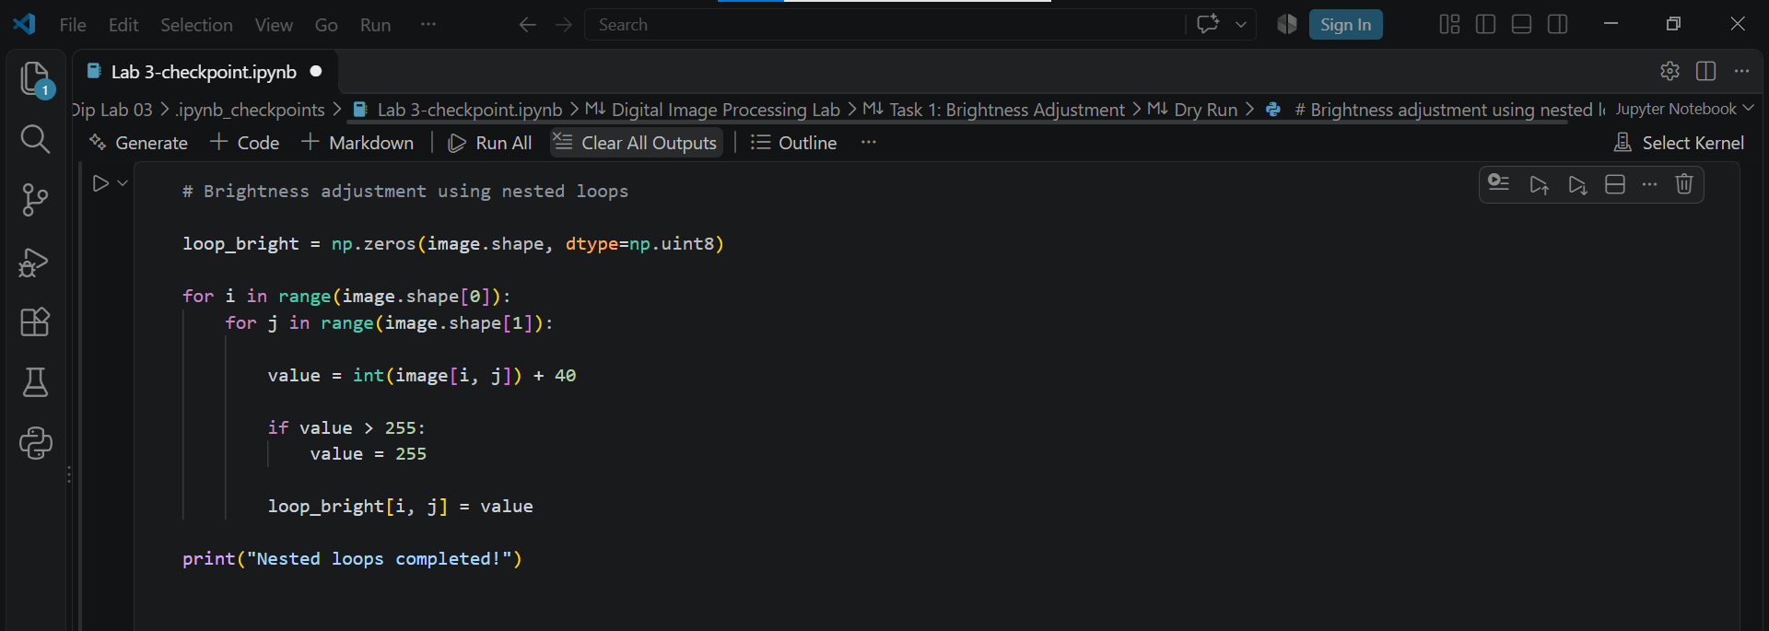
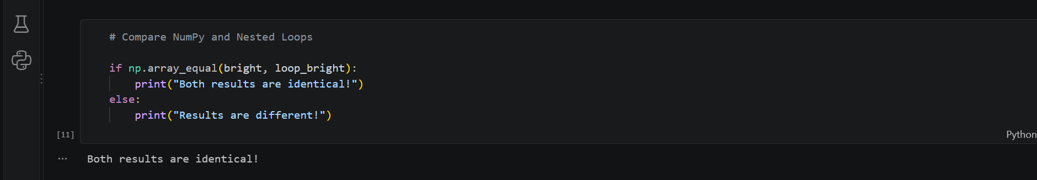

Observation: Adding 40 increases brightness, while subtracting 40 decreases brightness. Clipping prevents values from exceeding the valid range.

TASK 2: Linear Contrast from Zero
Objective: To increase image contrast using a linear transformation.
Formula:
s = αr + β
Where:
α = 1.5
β = 0

Dry Run
Original pixels:
[30, 80, 128, 180, 240]
Calculations:
- 30 × 1.5 = 45
- 80 × 1.5 = 120
- 128 × 1.5 = 192
- 180 × 1.5 = 270 → 255
- 240 × 1.5 = 360 → 255
Final output:
[45, 120, 192, 255, 255]

Practical Steps
- Convert the original image into float32.
- Multiply every pixel by 1.5.
- Clip the values between 0 and 255.
- Convert the result into uint8.
- Display the original and enhanced images.
- Compare their brightness and contrast.
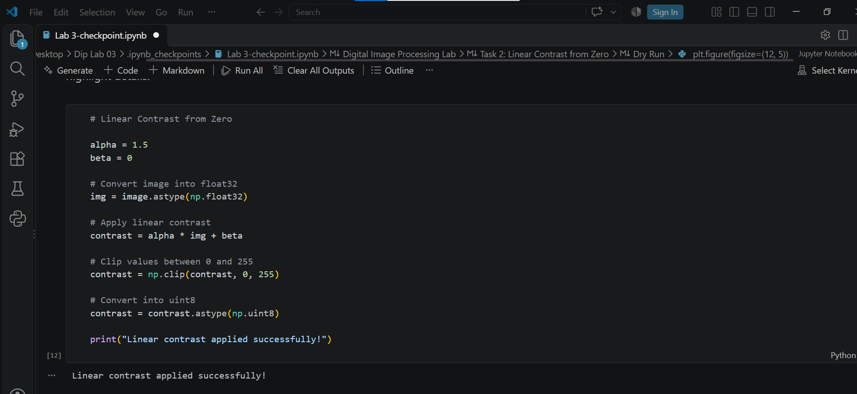
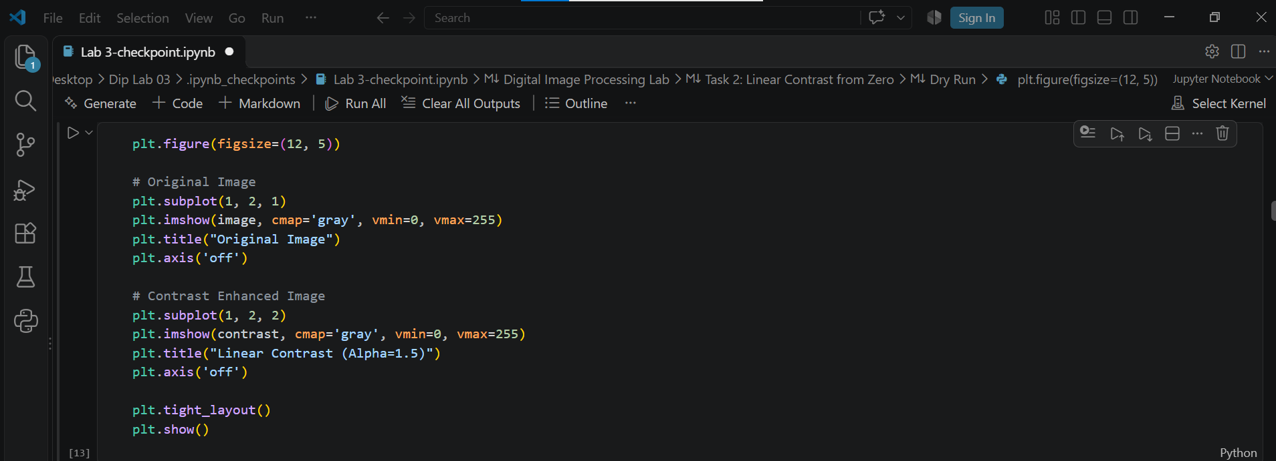
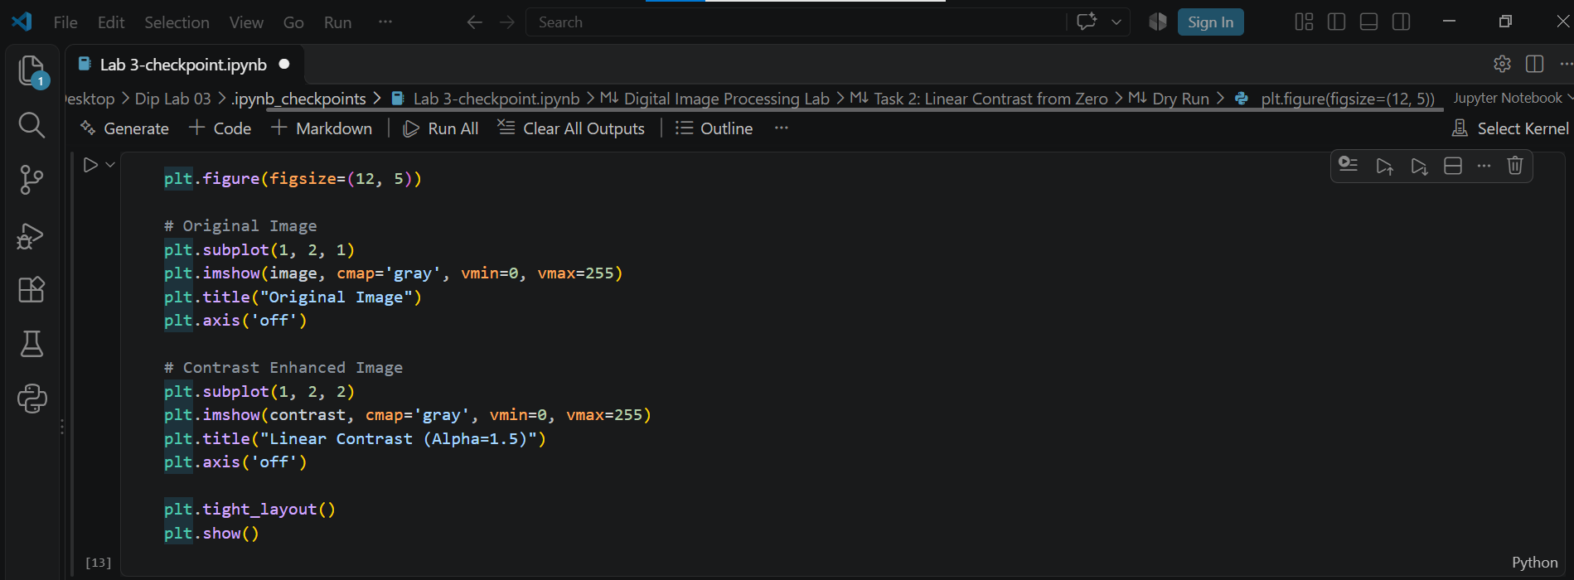
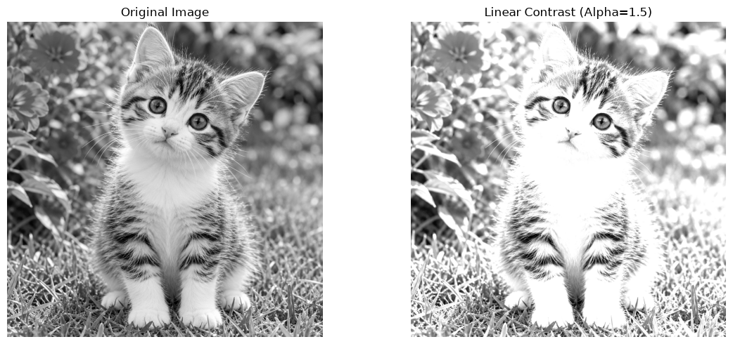
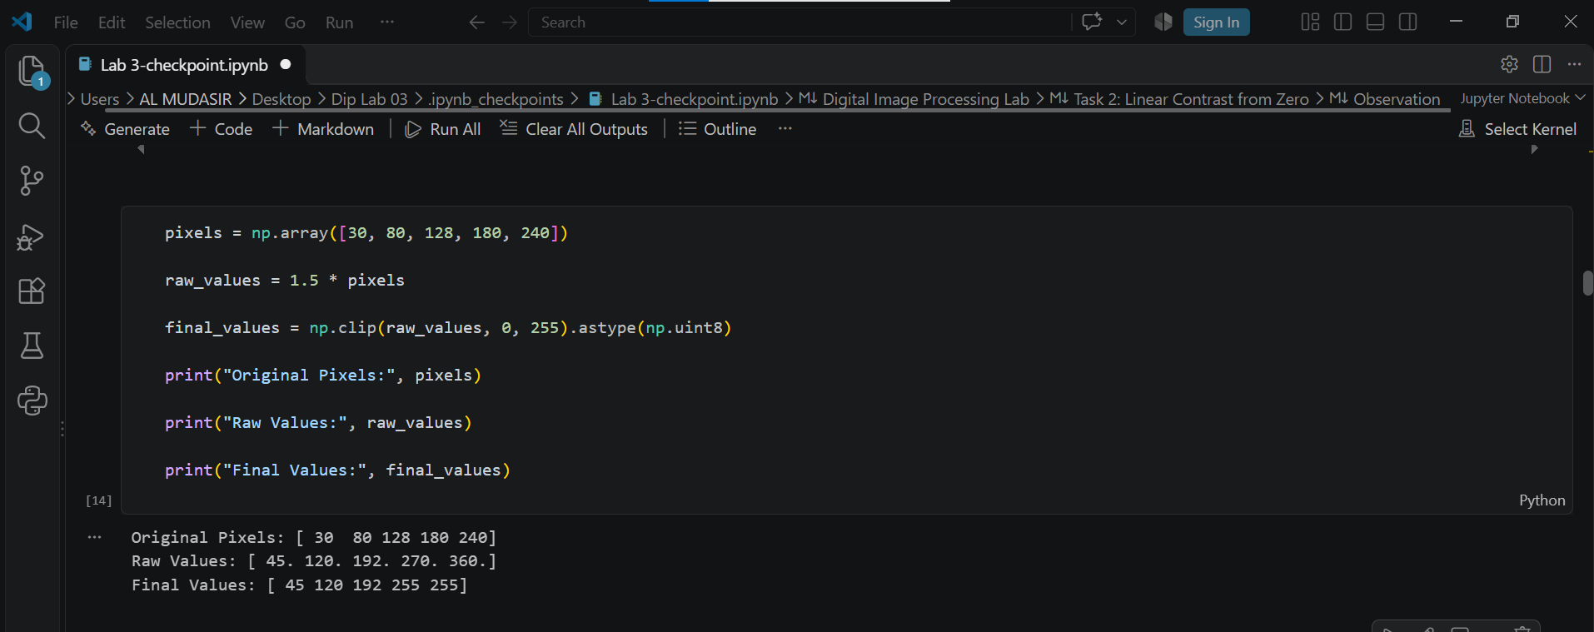

Observation: Increasing the contrast factor makes the image intensity values more spread out. Higher values may become saturated at 255, causing loss of highlight details.

TASK 3: Contrast Centered at 128
Objective: To increase and decrease contrast around the middle grayscale value 128.
Formula:
s = (r − 128)α + 128
Parameters:
α = 1.5 and α = 0.5

Dry Run
Original pixels:
[30, 80, 128, 180, 240]
For α = 1.5
- (30 − 128) × 1.5 + 128 = −19 → 0
- (80 − 128) × 1.5 + 128 = 56
- (128 − 128) × 1.5 + 128 = 128
- (180 − 128) × 1.5 + 128 = 206
- (240 − 128) × 1.5 + 128 = 296 → 255
Final output:
[0, 56, 128, 206, 255]
For α = 0.5
- (30 − 128) × 0.5 + 128 = 79
- (80 − 128) × 0.5 + 128 = 104
- (128 − 128) × 0.5 + 128 = 128
- (180 − 128) × 0.5 + 128 = 154
- (240 − 128) × 0.5 + 128 = 184
Final output:
[79, 104, 128, 154, 184]

Practical Steps
- Convert the image into float32.
- Apply the formula using α = 1.5.
- Clip the values between 0 and 255.
- Repeat the process using α = 0.5.
- Convert both results into uint8.
- Display the original and both transformed images.
- Compare the results.
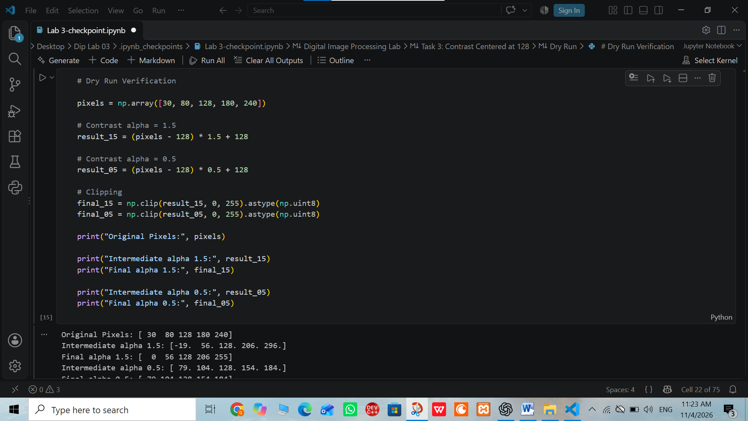
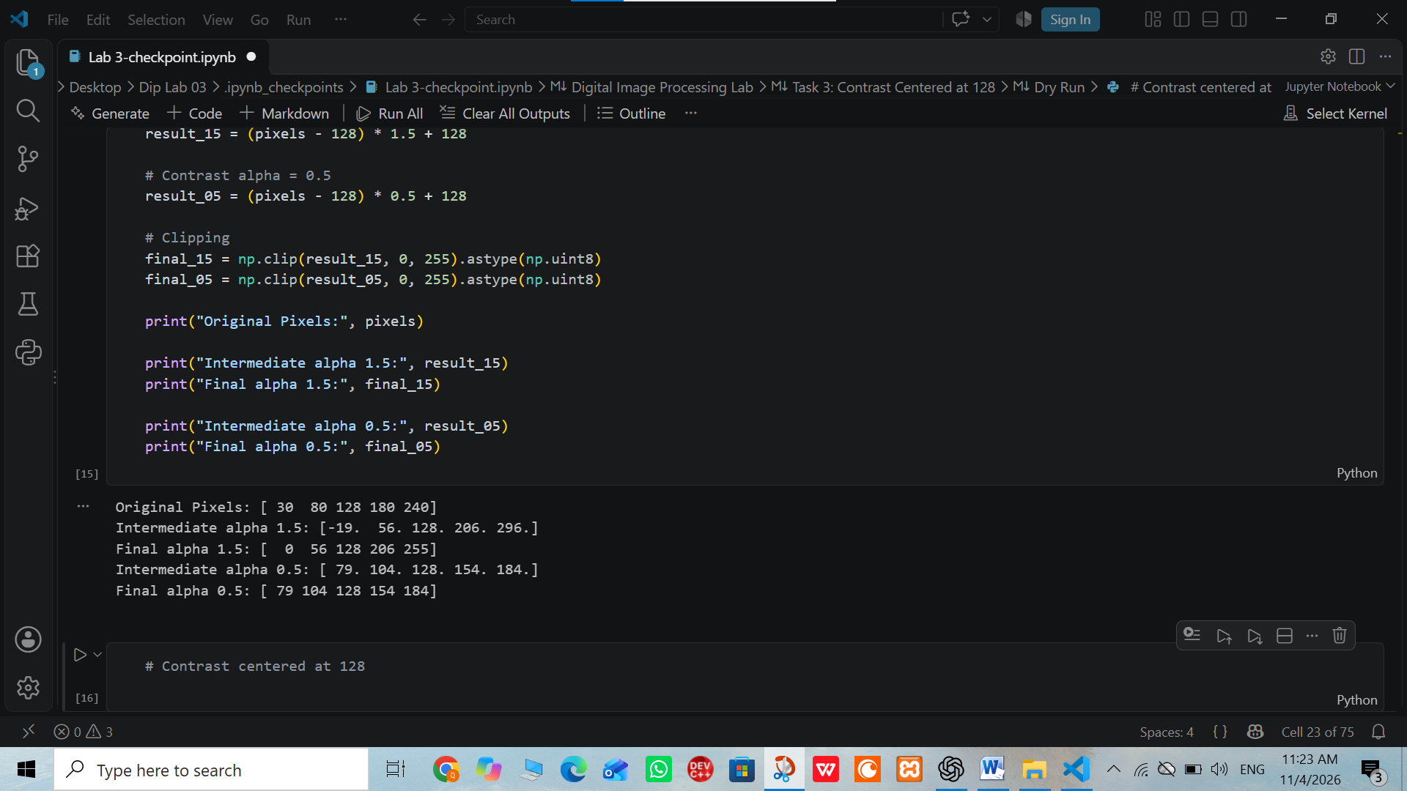
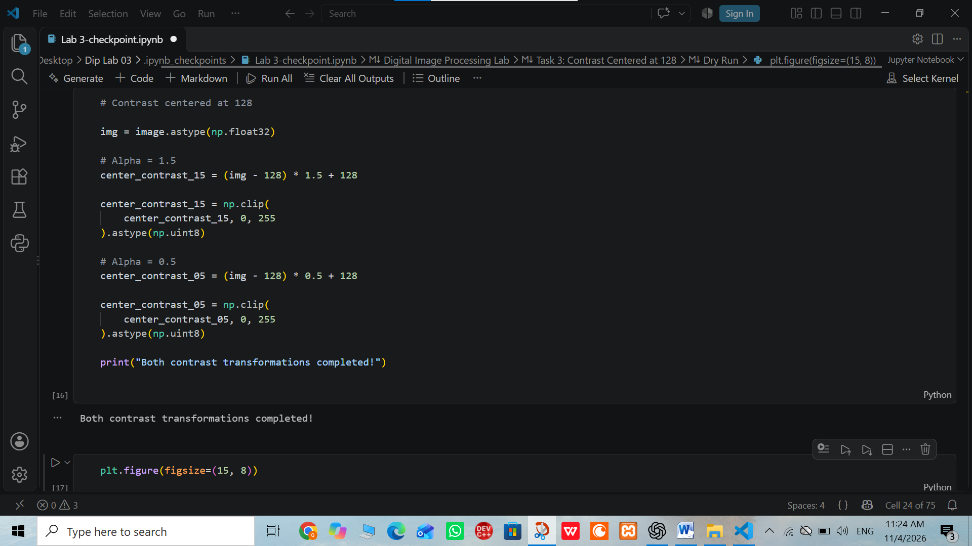
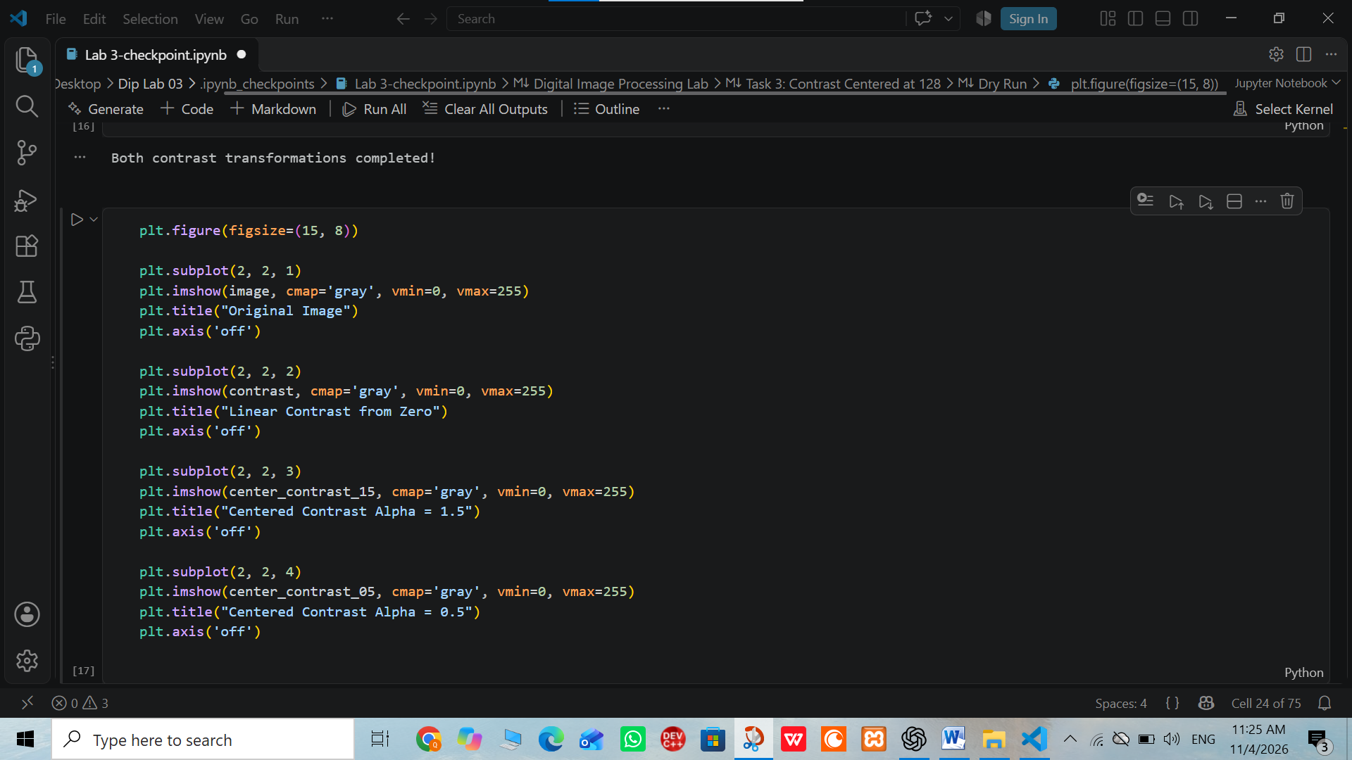
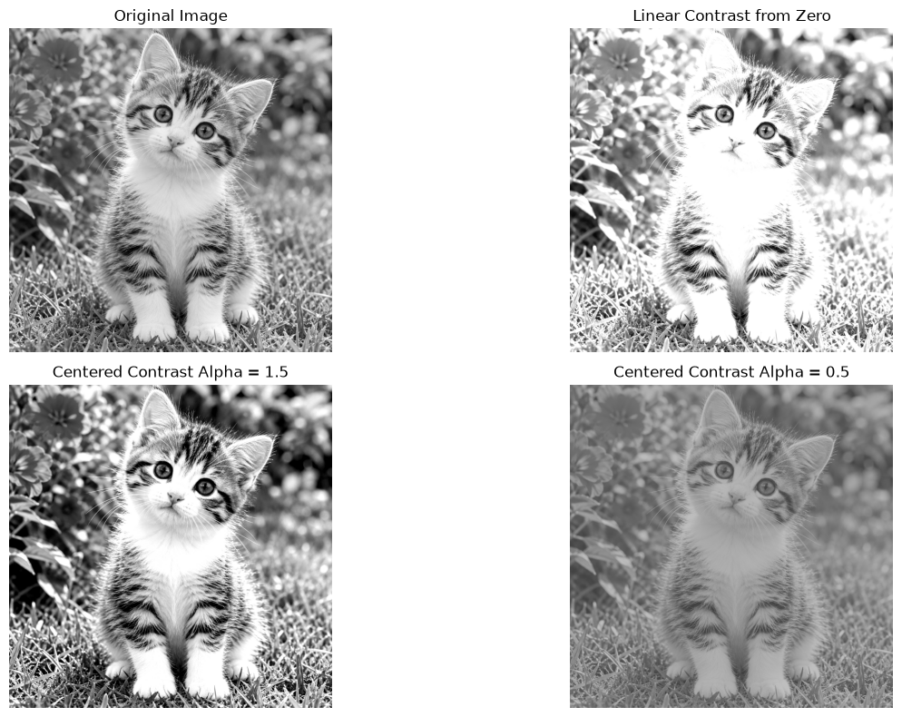

Observation: α = 1.5 increases contrast, while α = 0.5 decreases contrast. The pixel value 128 remains unchanged in both cases.

TASK 4: Image Negative
Objective: To create the negative of a grayscale image.
Formula:
s = 255 − r

Dry Run
Original pixels:
[30, 80, 128, 180, 240]
Calculations:
- 255 − 30 = 225
- 255 − 80 = 175
- 255 − 128 = 127
- 255 − 180 = 75
- 255 − 240 = 15
Final output:
[225, 175, 127, 75, 15]
Applying Negative Again
255 − 225 = 30
255 − 175 = 80
255 − 127 = 128
255 − 75 = 180
255 − 15 = 240
Original output:
[30, 80, 128, 180, 240]

Practical Steps
- Load the original grayscale image.
- Apply the formula 255 − r.
- Display the negative image.
- Apply the negative operation again.
- Compare the second negative with the original image.
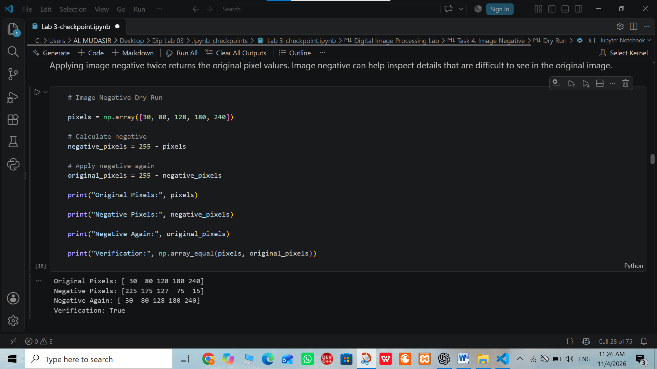
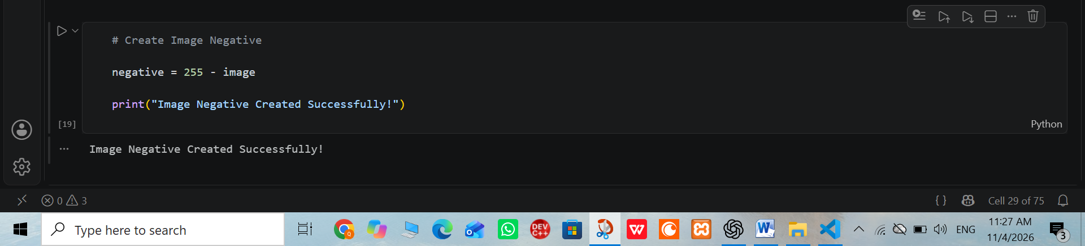
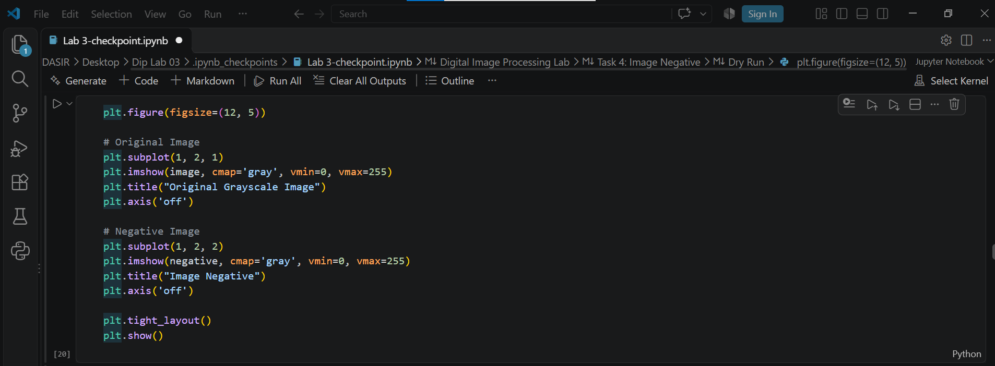
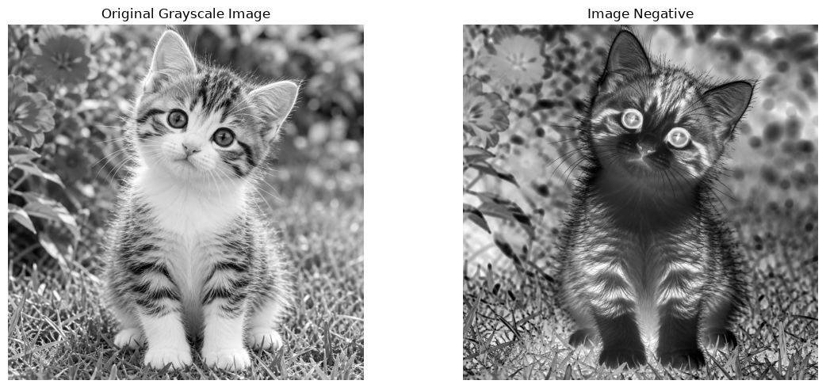

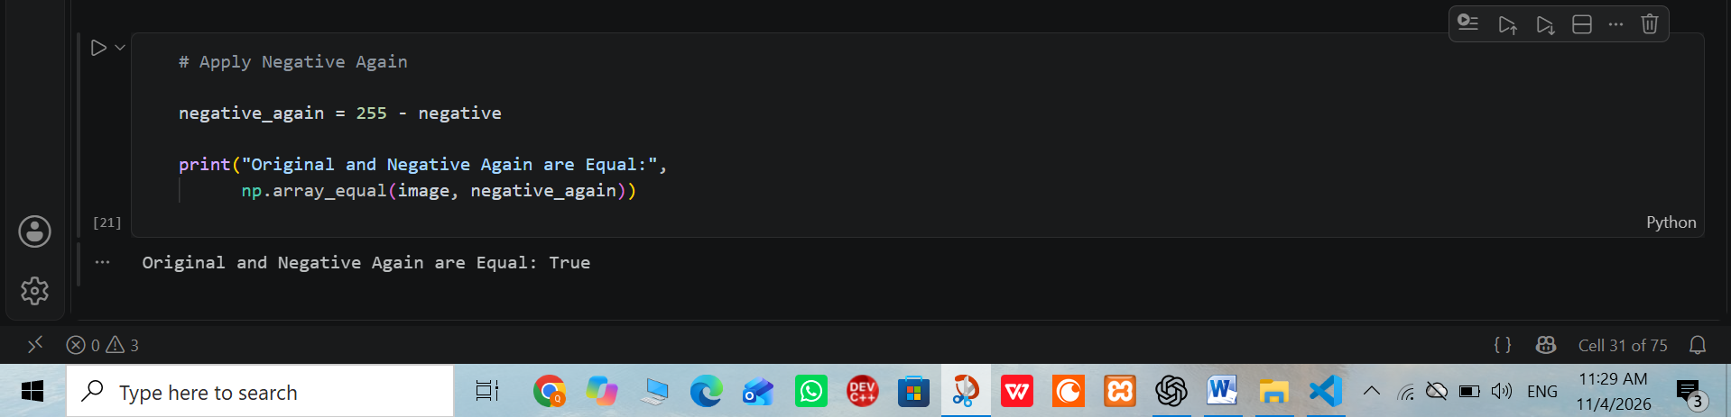

Observation: Applying the negative operation twice returns the original image. Image negatives can help inspect details that are difficult to see in the original image.

TASK 5: Gamma Correction
Objective: To adjust image brightness using gamma correction.
Formula:
s = 255(r/255)^γ
Parameters:
γ = 0.5 and γ = 2.0

Dry Run
Original pixels:
[0, 64, 128, 192, 255]
For γ = 0.5
- 255(0/255)^0.5 = 0
- 255(64/255)^0.5 = 127.750 → 127
- 255(128/255)^0.5 = 180.665 → 180
- 255(192/255)^0.5 = 221.269 → 221
- 255(255/255)^0.5 = 255
Final output:
[0, 127, 180, 221, 255]
For γ = 2.0
- 255(0/255)^2 = 0
- 255(64/255)^2 = 16.063 → 16
- 255(128/255)^2 = 64.251 → 64
- 255(192/255)^2 = 144.565 → 144
- 255(255/255)^2 = 255
Final output:
[0, 16, 64, 144, 255]

Practical Steps
- Convert the image into float64.
- Normalize pixel values by dividing by 255.
- Apply gamma correction with γ = 0.5.
- Repeat with γ = 2.0.
- Multiply the results by 255.
- Clip and convert the final values into uint8.
- Display the original and both gamma-corrected images.
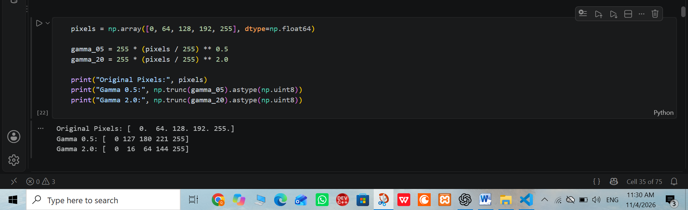
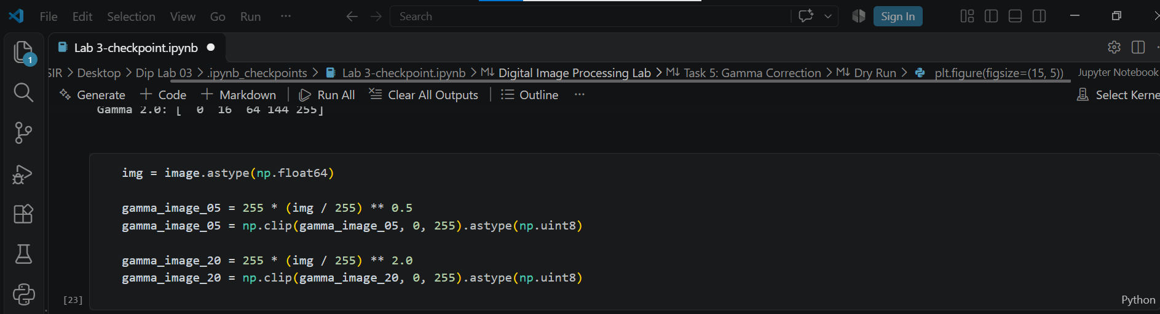
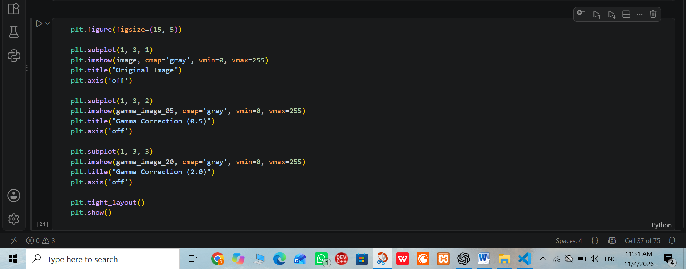
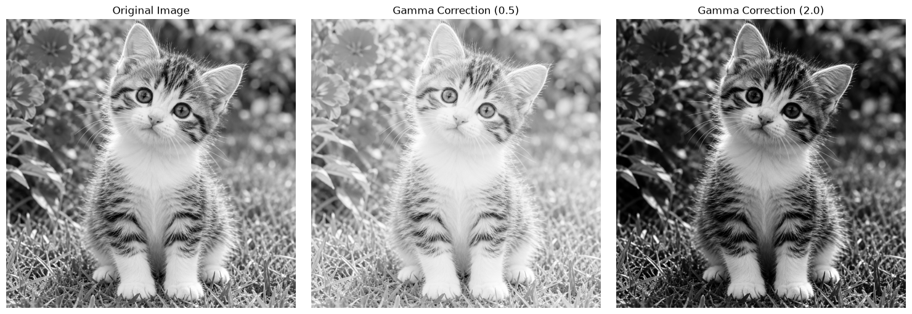

Observation: Gamma 0.5 brightens the image, while gamma 2.0 darkens it. The pixel values 0 and 255 remain unchanged.

TASK 6: Grayscale Histogram
Objective: To calculate and display the frequency of grayscale intensity values.

Practical Steps
- Load the original grayscale image.
- Calculate a histogram using 256 bins.
- Set the intensity range from 0 to 256.
- Plot the histogram using Matplotlib.
- Label the x-axis as Intensity and the y-axis as Frequency.
- Add a title to the histogram.
- Interpret the intensity distribution in two sentences.
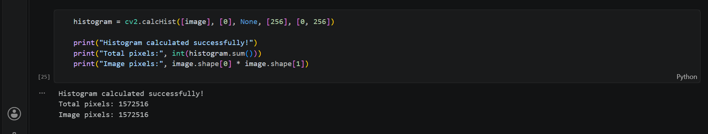
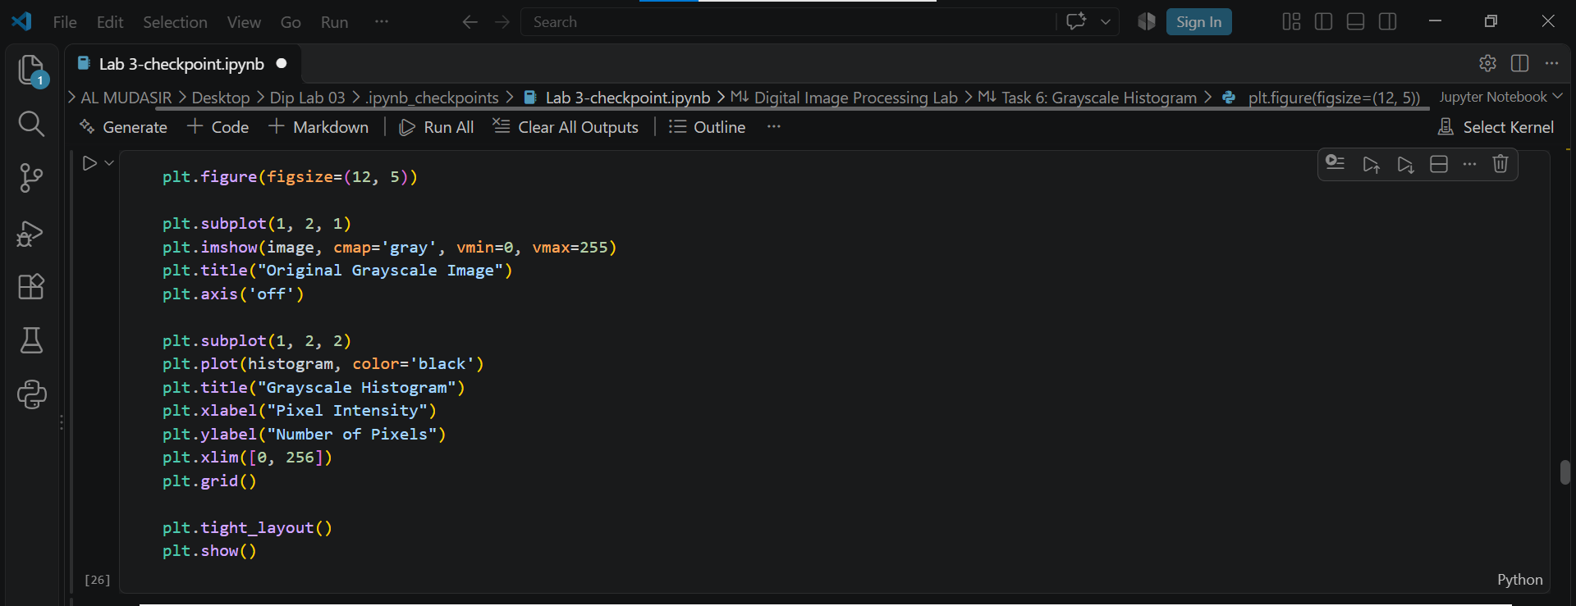
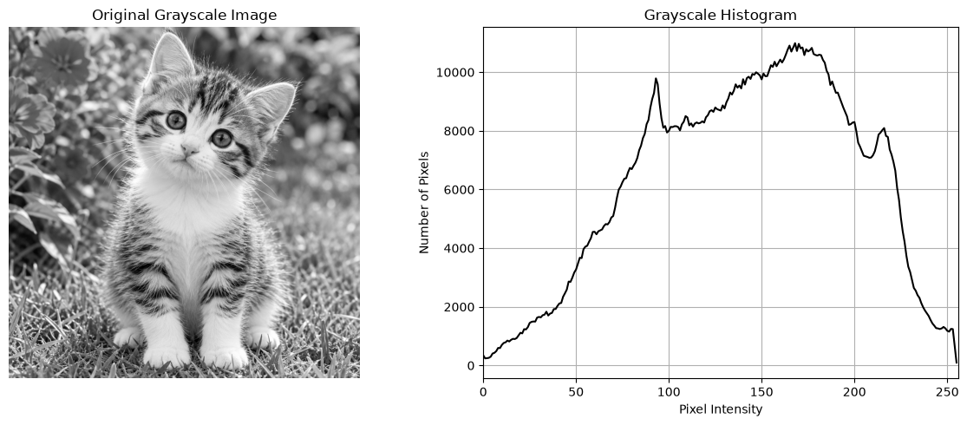
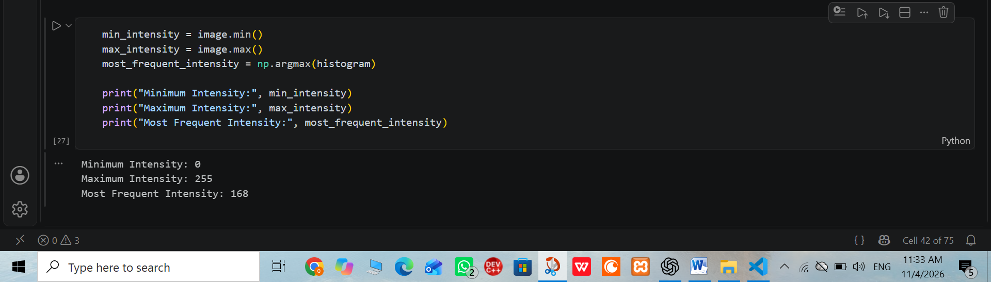

Dry Run
Given matrix:
A = [[0, 50, 50, 100],
[100, 150, 200, 255]]
Total number of pixels = 8.
Intensity | Frequency | Probability
0 | 1 | 0.125
50 | 2 | 0.250
100 | 2 | 0.250
150 | 1 | 0.125
200 | 1 | 0.125
255 | 1 | 0.125
Total | 8 | 1.000
Observation: A histogram shows how frequently each intensity value occurs. It does not show the actual positions of pixels in an image.

TASK 7: Global Histogram Equalization
Objective: To improve overall image contrast using histogram equalization.

Practical Steps
- Load the grayscale image.
- Apply cv2.equalizeHist() to the original image.
- Display the original and equalized images.
- Calculate the histogram of both images.
- Display both histograms.
- Compare the contrast and image details.
- Explain whether noise becomes more visible.
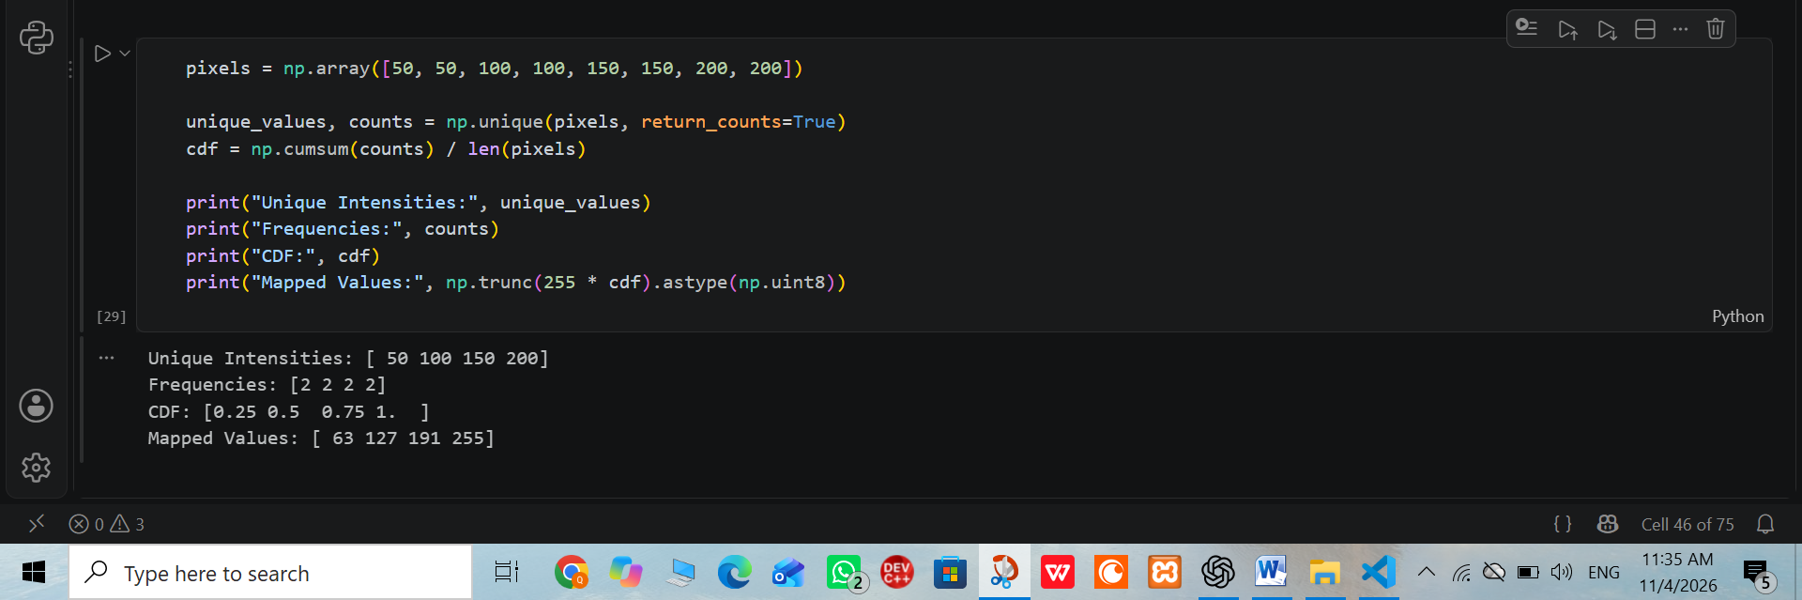
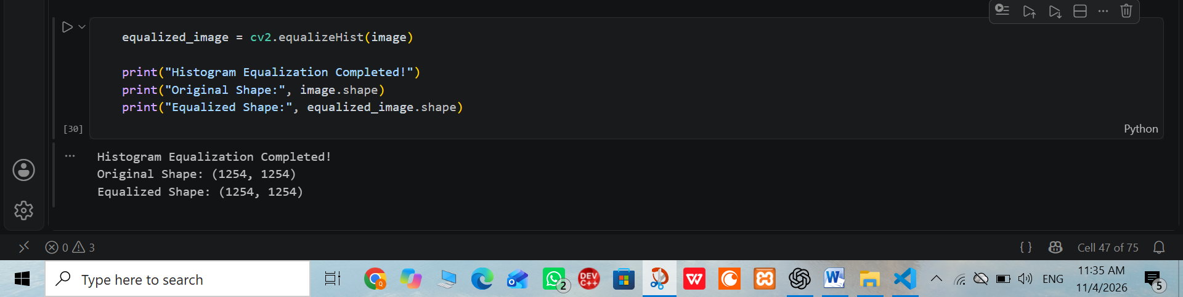
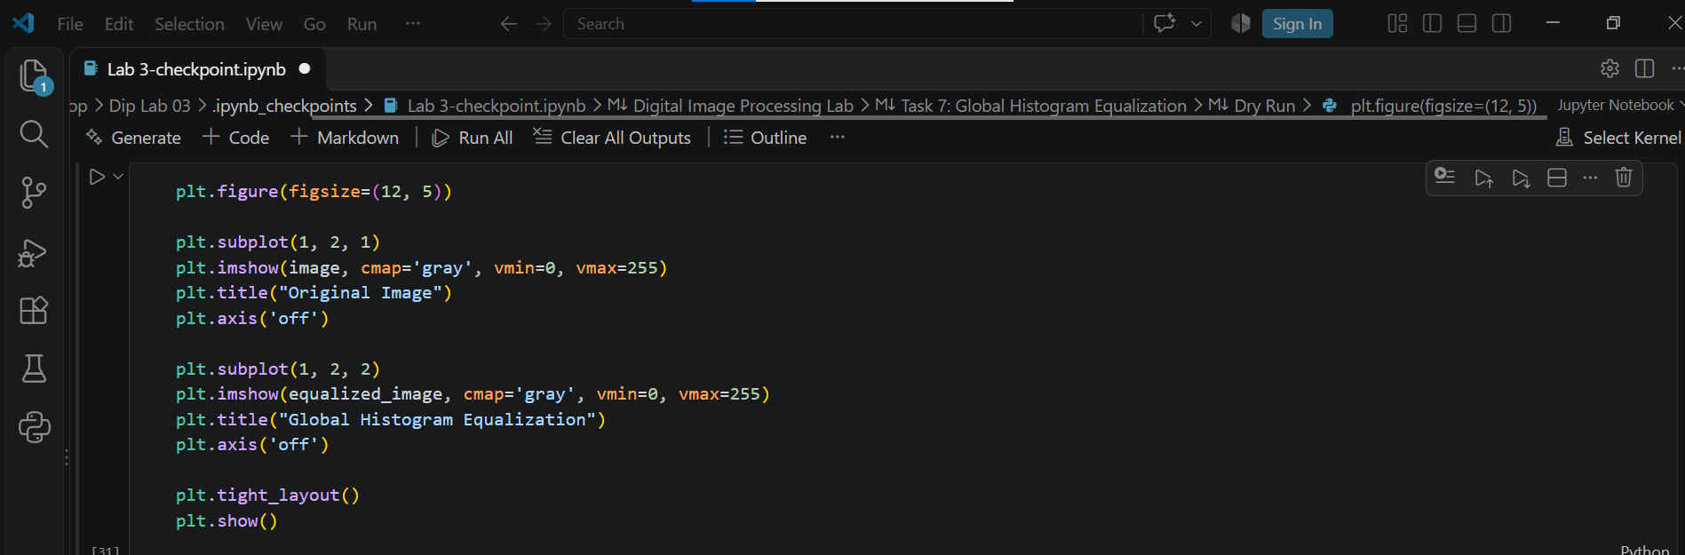
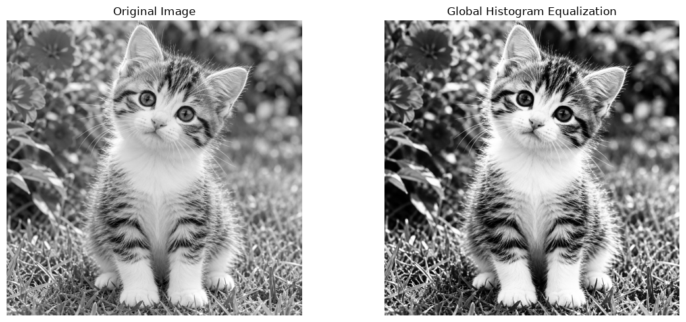
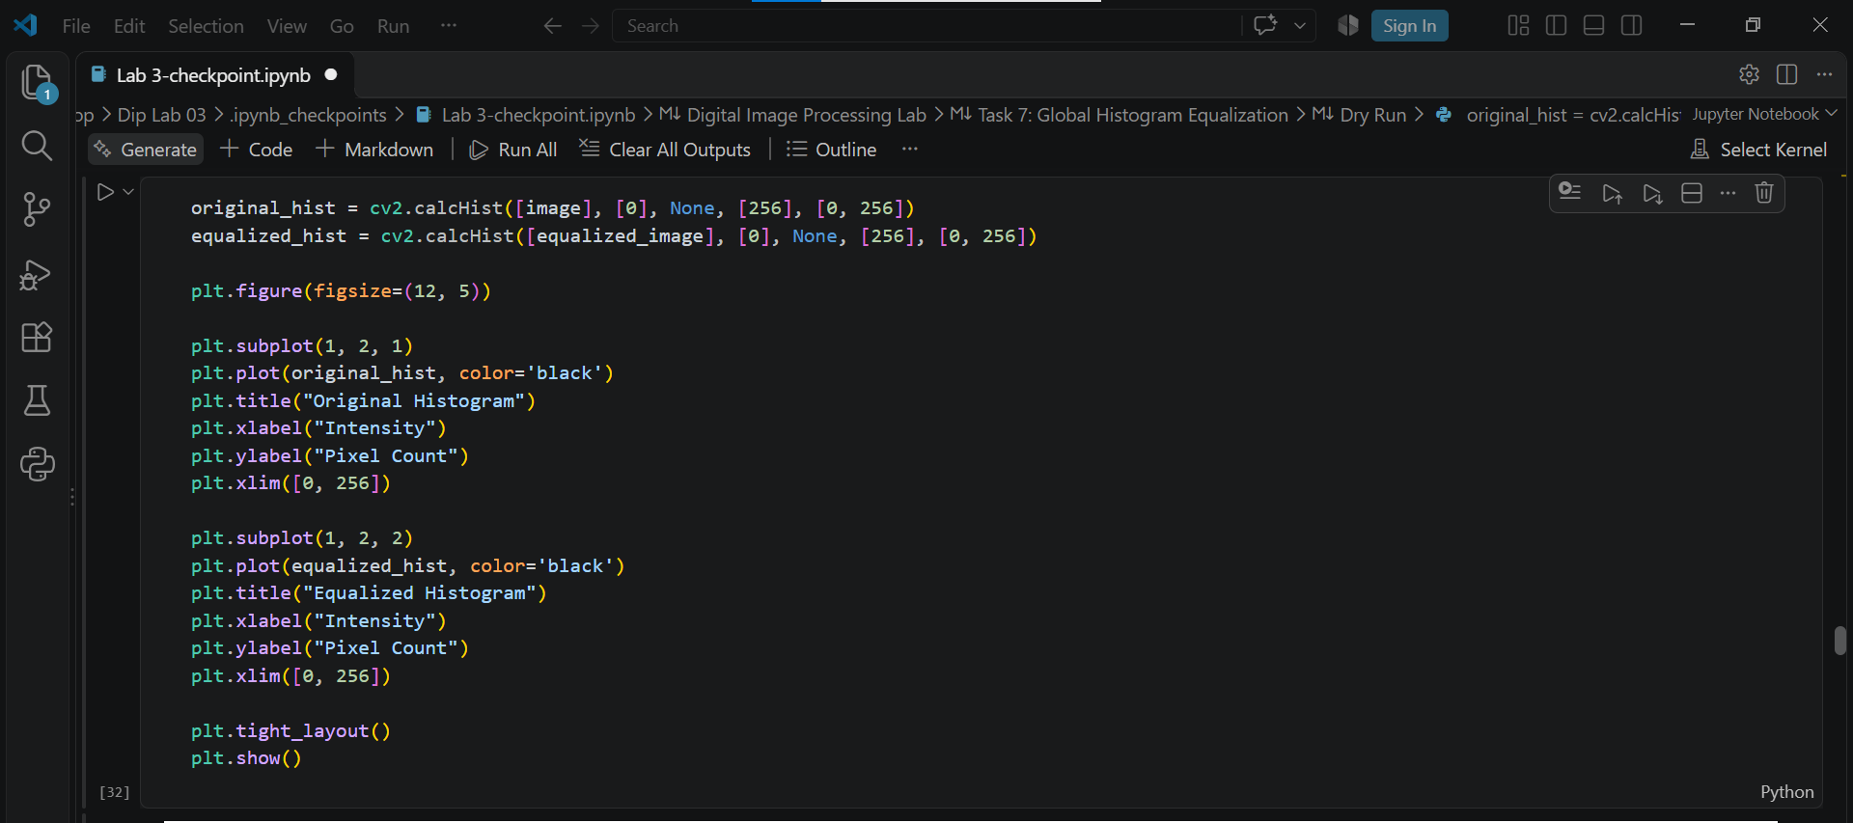
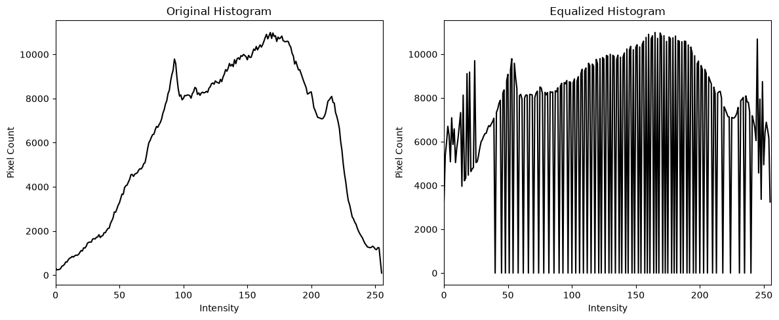

Dry Run
Given pixels:
[50, 50, 100, 150]
Frequency distribution:
Intensity | Frequency | Cumulative Count | CDF
50 | 2 | 2 | 0.50
100 | 1 | 3 | 0.75
150 | 1 | 4 | 1.00
Total pixels = 4.
First Mapping
Formula:
New Value = 255 × CDF
For 50:
255 × 0.50 = 127.5 → 128
For 100:
255 × 0.75 = 191.25 → 191
For 150:
255 × 1.00 = 255
Output:
[128, 128, 191, 255]
Second Mapping
Formula:
New Value = 255 × (CDF − CDFmin)/(1 − CDFmin)
CDFmin = 0.50
For 50:
255 × (0.50 − 0.50)/(1 − 0.50) = 0
For 100:
255 × (0.75 − 0.50)/(1 − 0.50) = 127.5 → 128
For 150:
255 × (1.00 − 0.50)/(1 − 0.50) = 255
Output:
[0, 0, 128, 255]
Observation: Global histogram equalization improves overall image contrast by redistributing intensity values. However, it can also make image noise more visible.

TASK 8: CLAHE
Objective: To improve local image contrast using Contrast Limited Adaptive Histogram Equalization.
Parameters:
- clipLimit = 2.0
- tileGridSize = (8, 8)

Practical Steps
- Load the grayscale image.
- Create a CLAHE object using cv2.createCLAHE().
- Set clipLimit to 2.0.
- Set tileGridSize to (8, 8).
- Apply CLAHE to the original image.
- Display the original and CLAHE images.
- Plot their histograms.
- Compare CLAHE with global histogram equalization.
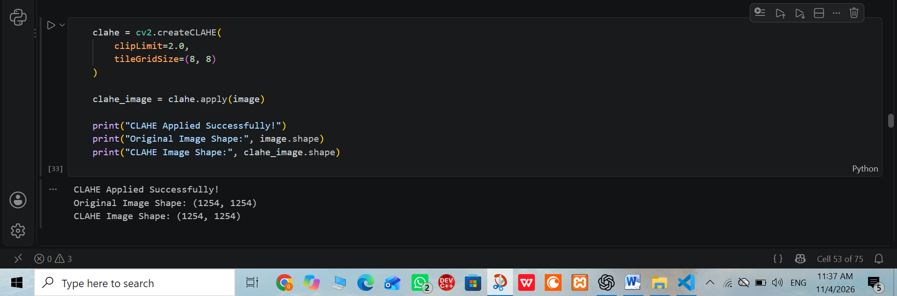
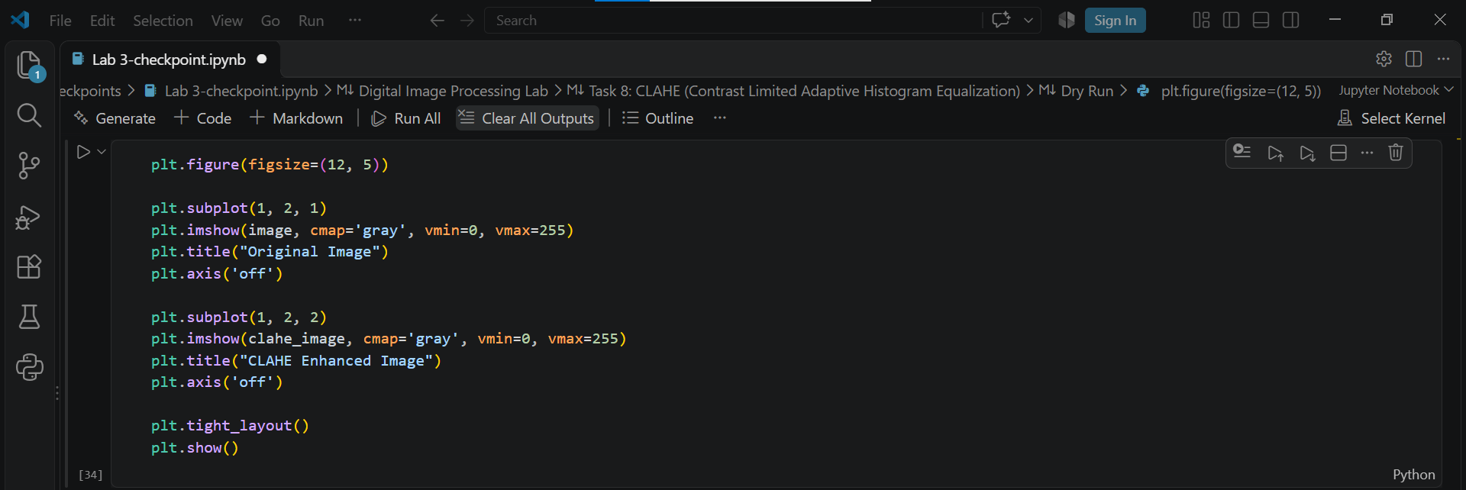
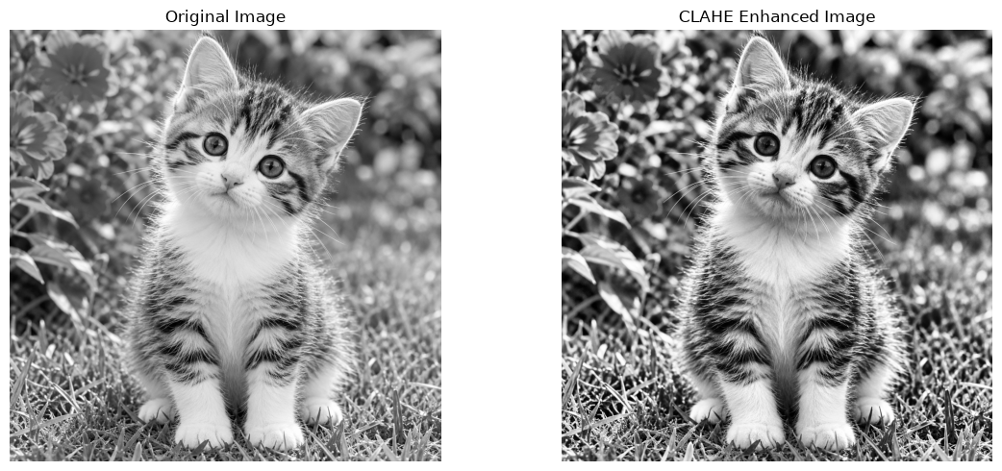
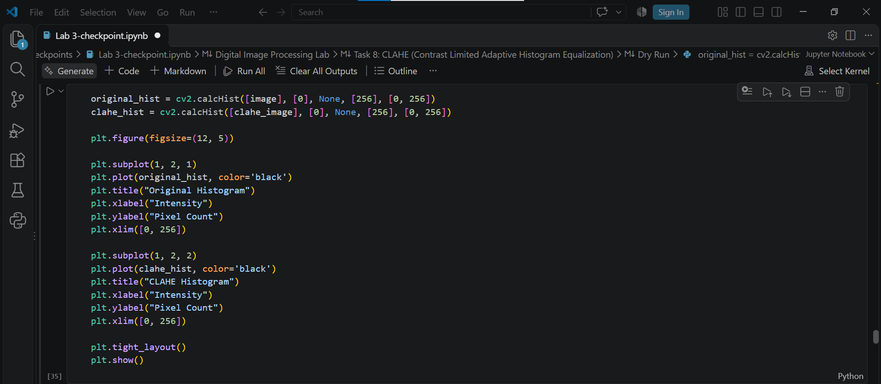
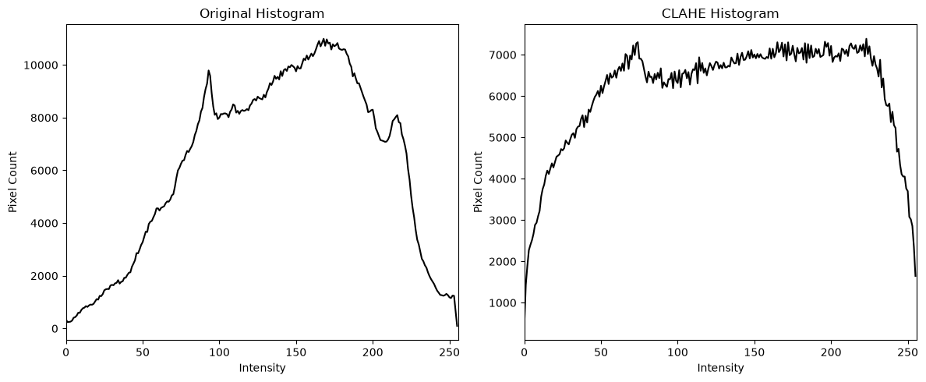

Note: (8, 8) represents the number of tiles across and down, not the number of pixels in each tile.

Dry Run
Given histogram:
[6, 2, 0, 0]
Absolute bin cap = 4
Step 1: Clipping
Original histogram:
[6, 2, 0, 0]
After clipping:
[4, 2, 0, 0]
Excess = 2
Step 2: Redistribution
Excess is divided equally among four bins:
2 ÷ 4 = 0.5
New histogram:
[4.5, 2.5, 0.5, 0.5]
Step 3: Calculate CDF
Cumulative counts:
[4.5, 7.0, 7.5, 8.0]
Total pixels = 8
CDF:
- 4.5 ÷ 8 = 0.5625
- 7.0 ÷ 8 = 0.8750
- 7.5 ÷ 8 = 0.9375
- 8.0 ÷ 8 = 1.0000
Observation: CLAHE improves local contrast and is useful when different regions of an image have uneven lighting. Interpolation between neighboring tiles helps prevent visible boundaries. This dry-run redistribution is a simplified model and is not the exact OpenCV implementation.

TASK 9: Fixed Binary Thresholding
Objective: To convert a grayscale image into a black-and-white image using a fixed threshold.
Formula:
If r > T, output = 255.
Otherwise, output = 0.
Threshold T = 127

Practical Steps
- Load the grayscale image.
- Apply cv2.threshold().
- Set threshold value to 127.
- Set maximum value to 255.
- Use cv2.THRESH_BINARY.
- Display the binary image.
- Find the unique pixel values using np.unique().
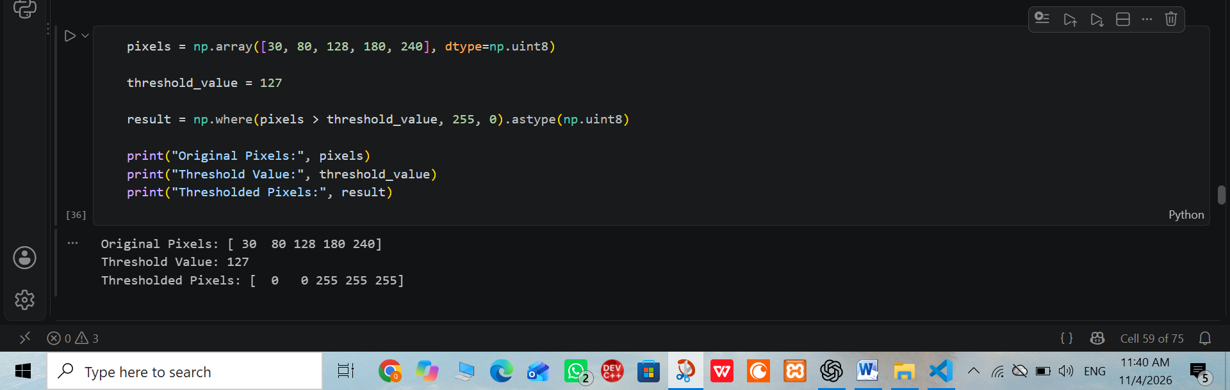
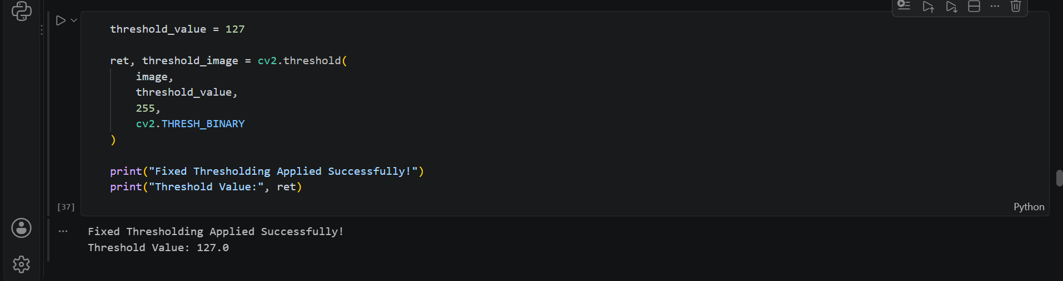
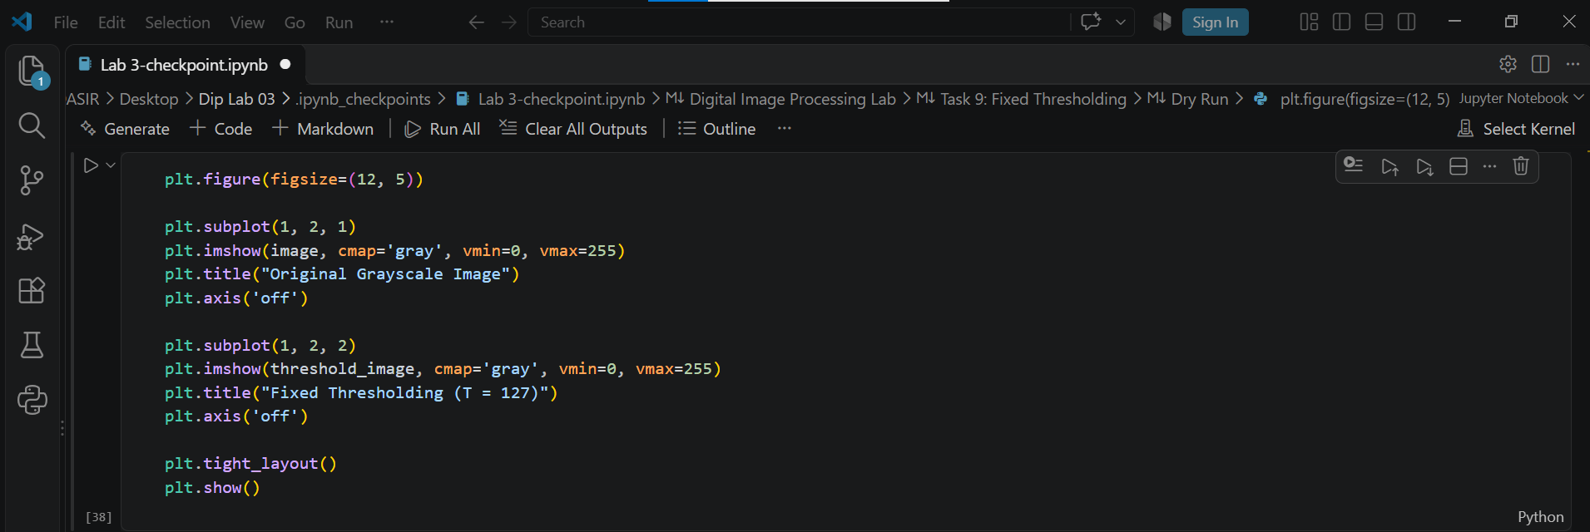
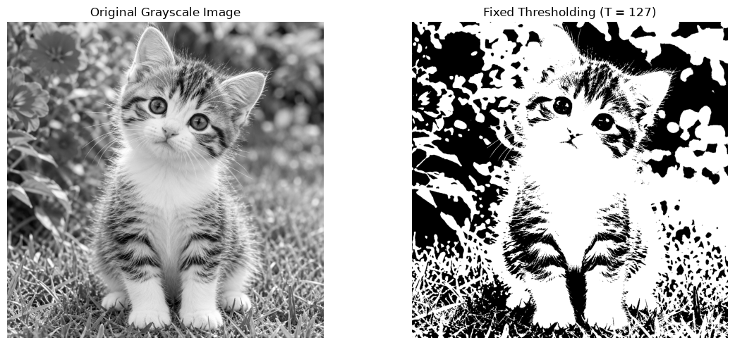

Dry Run
Given pixels:
[0, 80, 127, 128, 180, 255]
For T = 127
Output:
[0, 0, 0, 255, 255, 255]
White pixels = 3
For T = 180
Output:
[0, 0, 0, 0, 0, 255]
White pixels = 1
Observation: Fixed thresholding converts an image into black and white. Pixels greater than the threshold become white, while the remaining pixels become black.

TASK 10: Otsu Thresholding
Objective: To automatically calculate an appropriate threshold for binary image segmentation.

Practical Steps
- Load the grayscale image.
- Apply cv2.threshold().
- Use cv2.THRESH_BINARY + cv2.THRESH_OTSU.
- Record the threshold returned by OpenCV.
- Display the Otsu threshold image.
- Compare it with the fixed-threshold image.
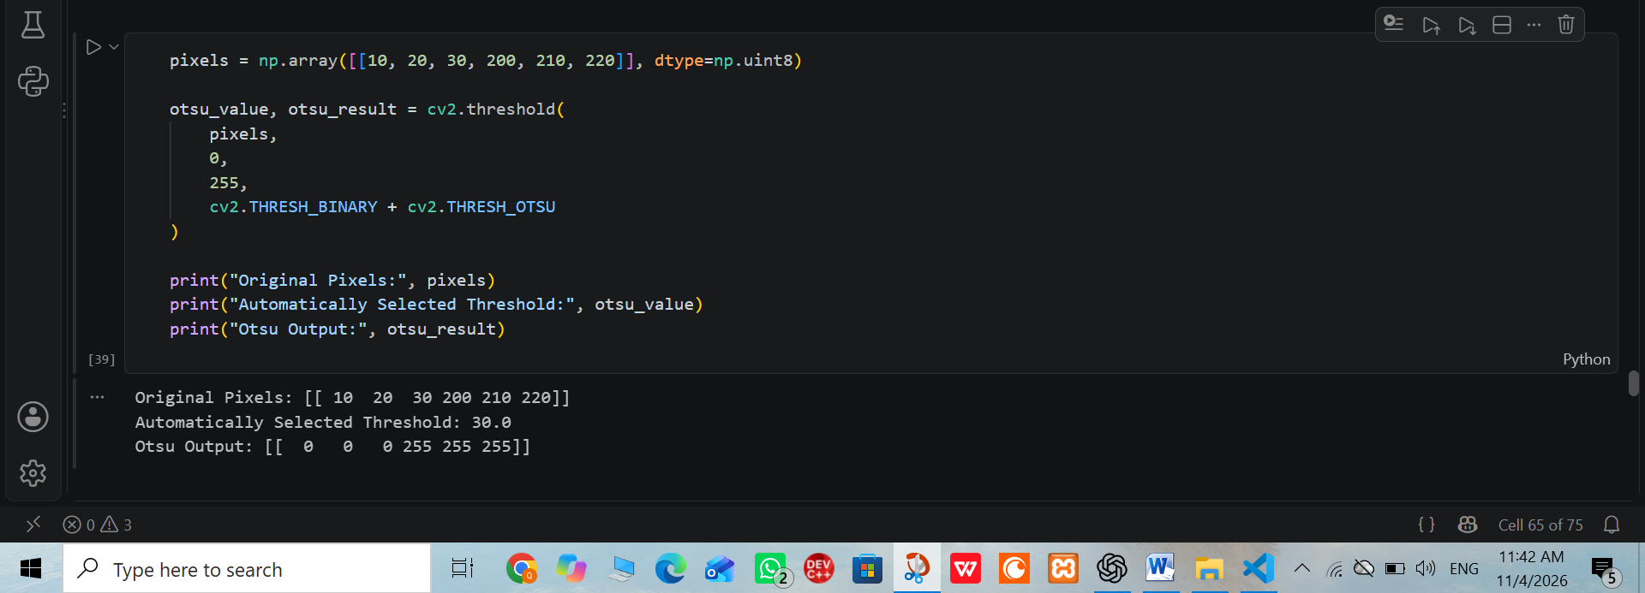
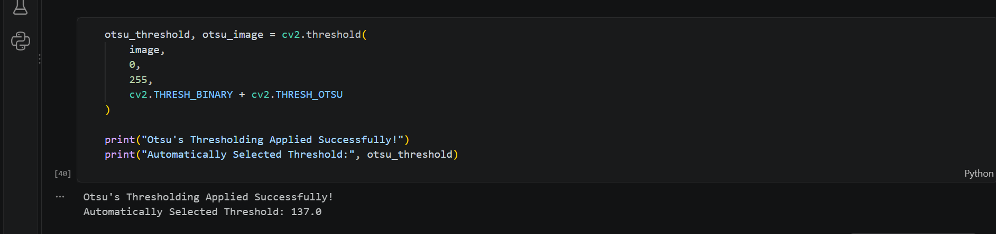
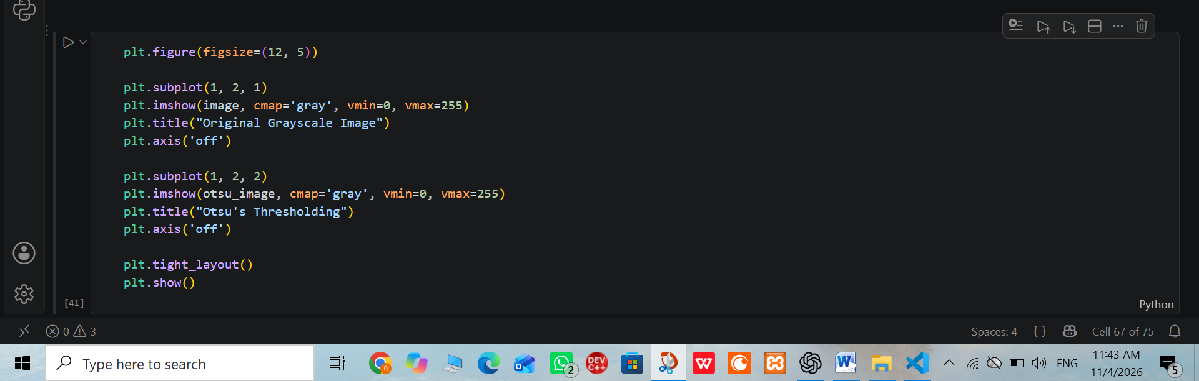
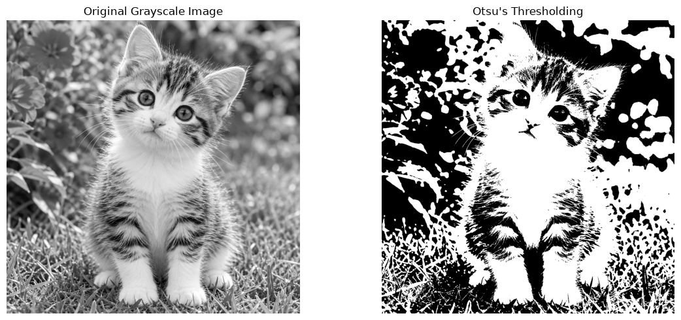

Dry Run
Given pixels:
[0, 1, 4, 5]
Test thresholds:
T = 0, 1, 2, 3, 4
Classes are divided into:
Class 0: r ≤ T
Class 1: r > T
Calculations
For T = 0:
Class 0 = [0]
Class 1 = [1, 4, 5]
w0 = 0.25
w1 = 0.75
μ0 = 0
μ1 = 3.333
Variance = 0.25 × 0.75 × (0 − 3.333)²
Variance = 2.083
For T = 1:
Class 0 = [0, 1]
Class 1 = [4, 5]
w0 = 0.50
w1 = 0.50
μ0 = 0.5
μ1 = 4.5
Variance = 0.50 × 0.50 × (0.5 − 4.5)²
Variance = 4.000
For T = 2:
Class 0 = [0, 1]
Class 1 = [4, 5]
Variance = 4.000
For T = 3:
Class 0 = [0, 1]
Class 1 = [4, 5]
Variance = 4.000
For T = 4:
Class 0 = [0, 1, 4]
Class 1 = [5]
w0 = 0.75
w1 = 0.25
μ0 = 1.667
μ1 = 5
Variance = 2.083
Final Result:
The maximum variance is 4.000 at T = 1, 2, and 3.
Choose the smallest threshold:
T = 1
Predicted binary output:
[0, 0, 255, 255]
Observation: Otsu thresholding automatically selects a threshold by maximizing the separation between two intensity classes.

TASK 11: Adaptive Gaussian Thresholding
Objective: To apply local thresholding using Gaussian-weighted neighboring pixels.
Parameters:
- Adaptive method: Gaussian
- Threshold type: Binary
- Block size: 11
- C = 2

Practical Steps
- Load the grayscale image.
- Apply cv2.adaptiveThreshold().
- Select Gaussian adaptive thresholding.
- Set maximum value to 255.
- Set blockSize to 11.
- Set C to 2.
- Display the resulting binary image.
- Compare it with fixed and Otsu thresholding.
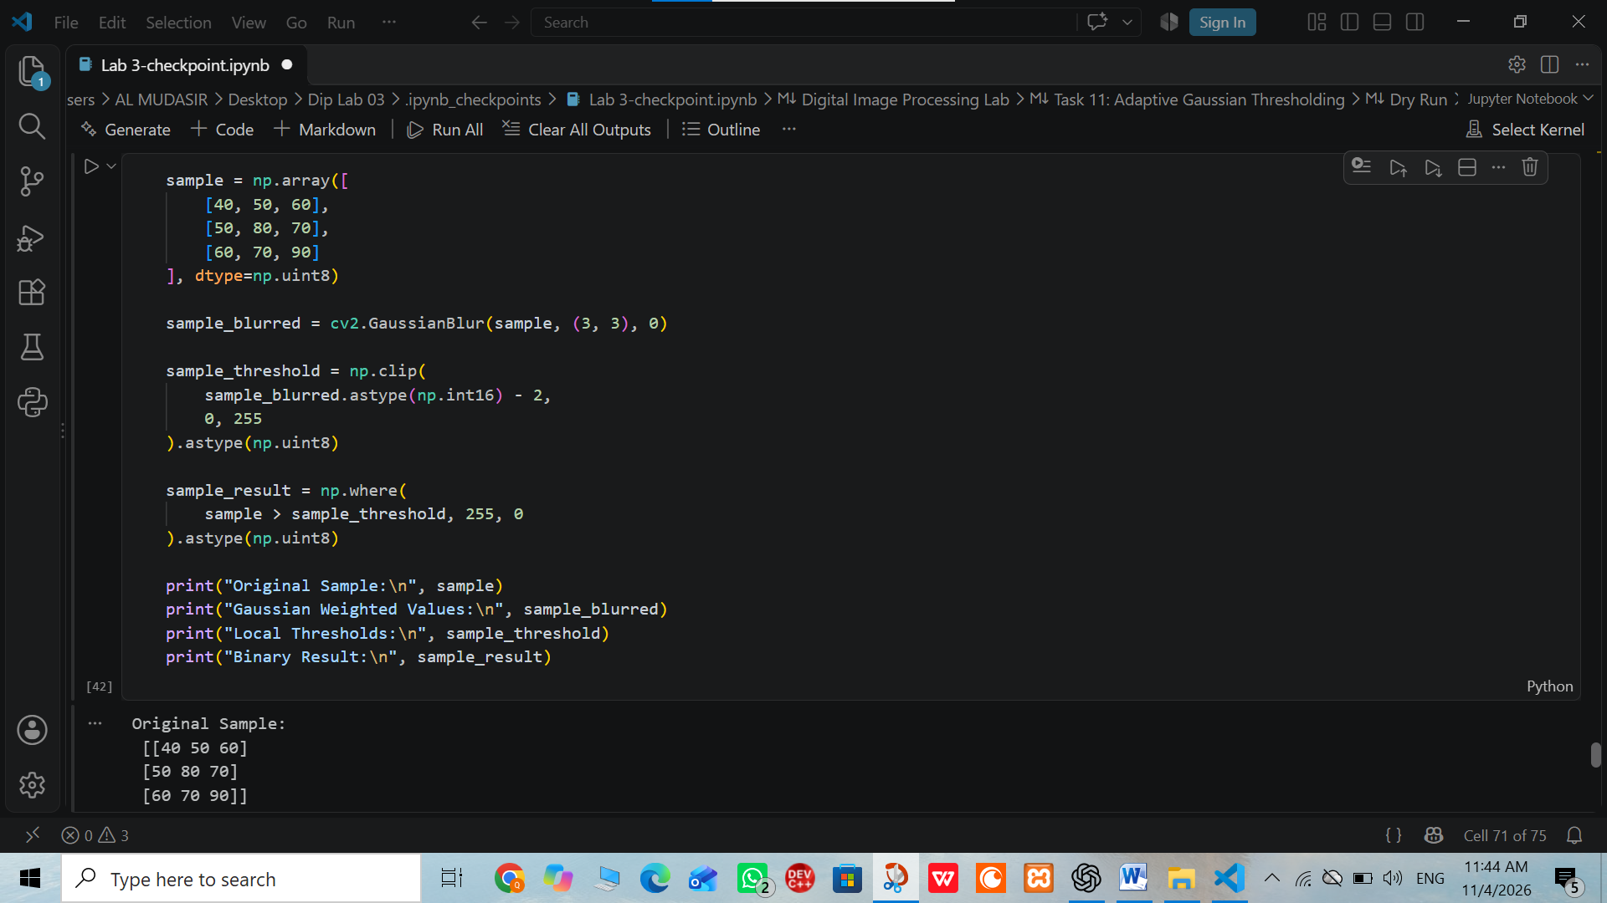
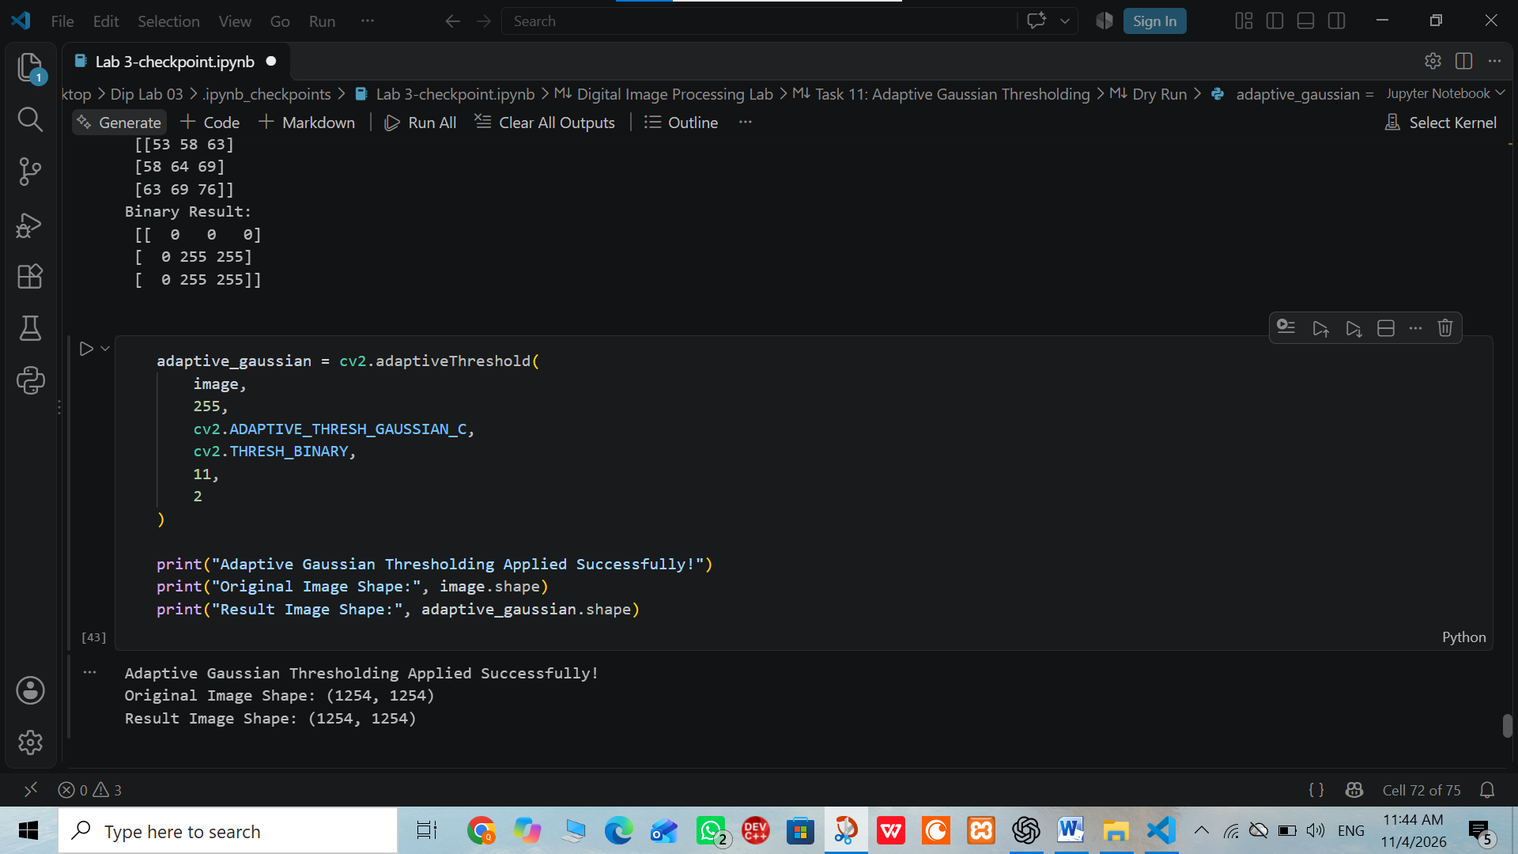
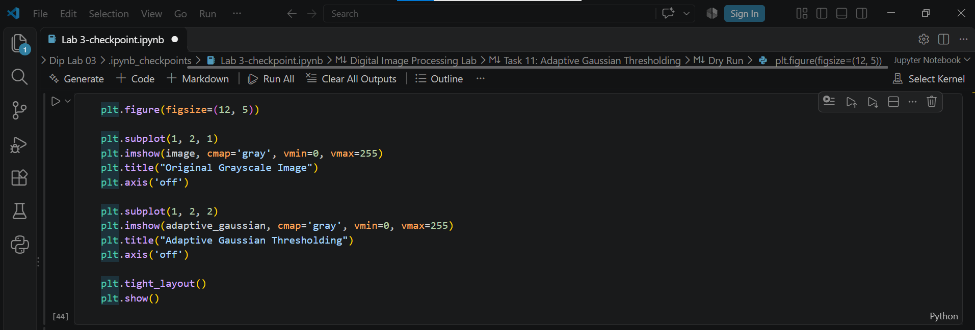
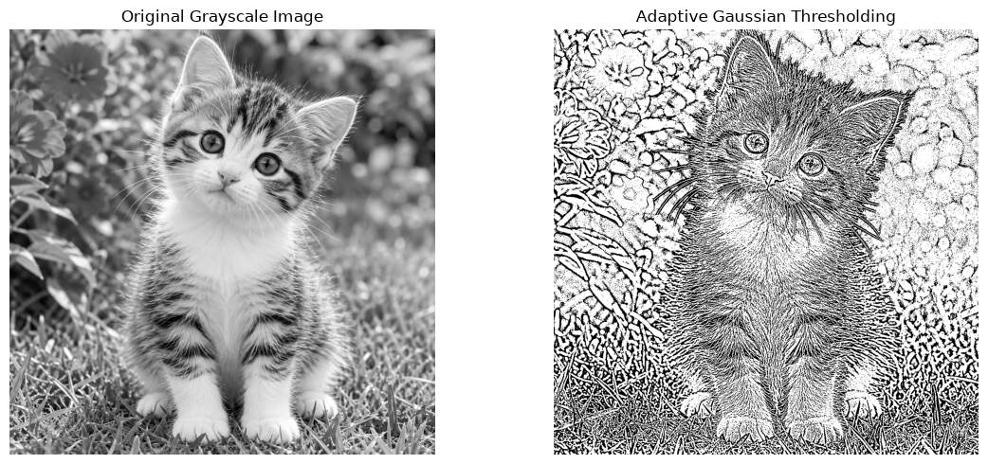

Dry Run
Given neighborhood:
[[100, 100, 100],
[100, 120, 140],
[140, 140, 140]]
Gaussian weights:
[[1, 2, 1],
[2, 4, 2],
[1, 2, 1]] / 16
Step 1: Calculate Weighted Mean
Top row:
100 × 1 + 100 × 2 + 100 × 1 = 400
Middle row:
100 × 2 + 120 × 4 + 140 × 2 = 960
Bottom row:
140 × 1 + 140 × 2 + 140 × 1 = 560
Total:
400 + 960 + 560 = 1920
Weighted mean:
1920 ÷ 16 = 120
Step 2: Calculate Threshold
Formula:
T = Mean − C
T = 120 − 2
T = 118
Step 3: Classify Center Pixel
Center pixel = 120
Since 120 > 118:
Output = 255
A pixel equal to 118 produces 0 because the condition is strictly greater than the threshold.
Observation: Adaptive Gaussian threshold.

